Scope of Work
The migration from AWS to Google Cloud Platform (GCP) focuses on two main workloads: data science and e-commerce.
For the data science workload, the transition involves moving from AWS EC2 GPU instances and SageMaker to Google Compute Engine and Vertex AI. Key tasks include setting up GPU instances on GCP, adapting models for Vertex AI, and transferring training data from AWS S3 to Google Cloud Storage. Move GPU instances from AWS EC2 to Google Compute Engine.
- Transition models from SageMaker to Vertex AI.
- Migrate data from AWS S3 to Google Cloud Storage.
For the e-commerce workload, AWS Lambda will move to Google Cloud Functions, Fargate to Cloud Run, and MySQL databases (1TB, with production and development environments, 10-12 flows, and 50 tables) to Google Cloud SQL. Data storage will shift from AWS S3 to Google Cloud Storage, CodeCommit will be replaced by Google Cloud Build, Cloud Deploy, and Artifact Registry. Logging will use Google Cloud Logging, monitoring will be done with Google Cloud Monitoring, and security will involve Google Cloud IAM and Security Command Center. Reporting will continue with Power BI.
- Migrate serverless functions from AWS Lambda to Google Cloud Functions.
- Transition containers from AWS Fargate to Google Cloud Run.
- Move MySQL databases to Google Cloud SQL and data to Google Cloud Storage.
- Replace CodeCommit with Google Cloud Build, Cloud Deploy, and Artifact Registry.
The migration will involve detailed planning, phased execution, and thorough testing. Post-migration support includes GCP training, comprehensive documentation, and ongoing monitoring to address any issues. The goal is a seamless transition with optimized performance and cost-efficiency.
- Conduct testing to ensure functionality and performance.
- Provide training and documentation for GCP.
- Implement monitoring with Google Cloud Monitoring, logging with Google Cloud Logging, and establish security practices using Google IAM and Security Command Center.

Architecture Diagram
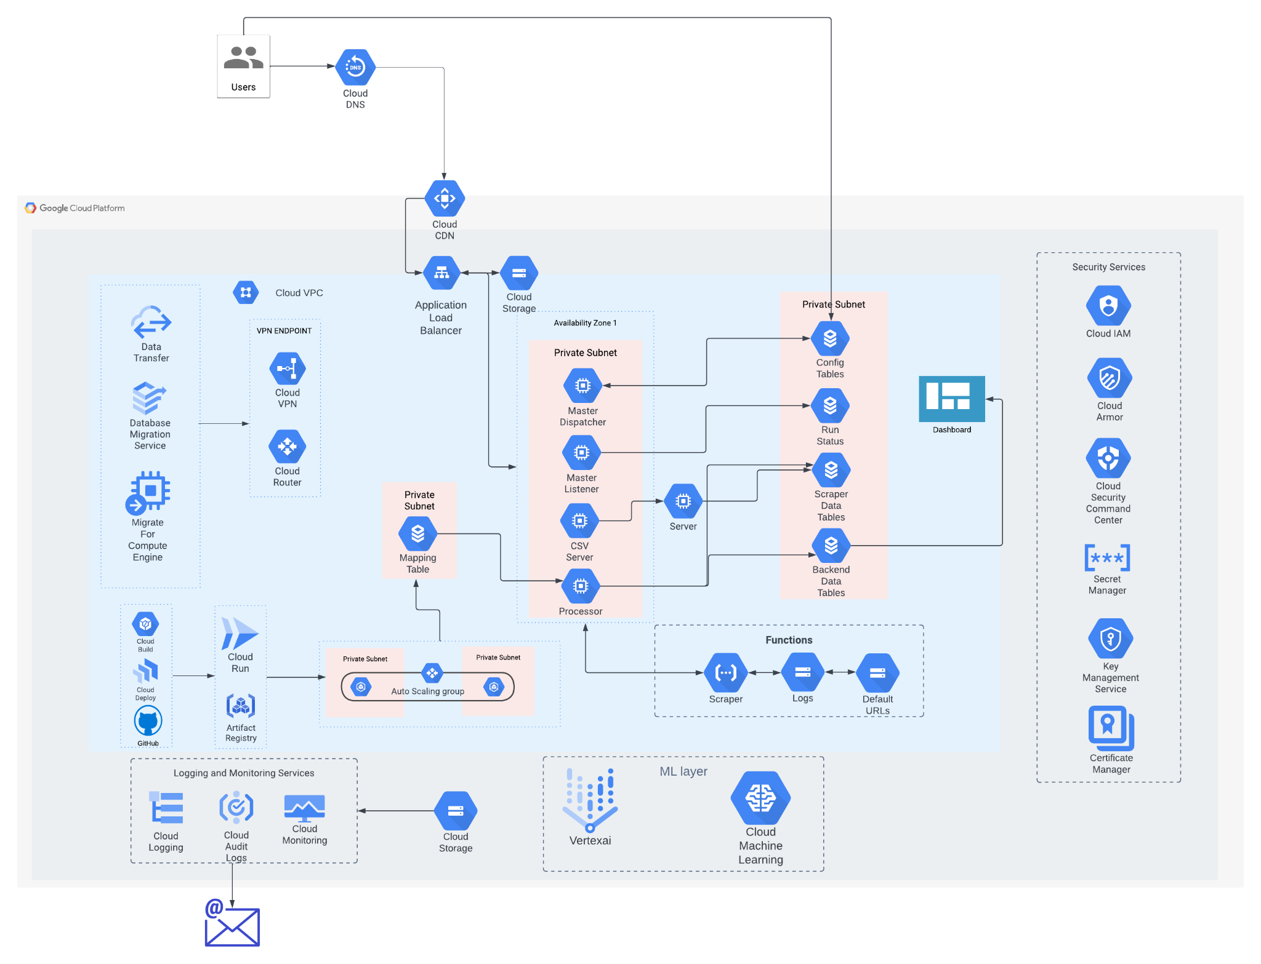

Architecture Description
Mfilter, a data science and e-commerce platform, requires a robust cloud infrastructure to handle its diverse workload. This architecture proposal outlines the key components and their interactions to ensure scalability, reliability, and security.
Master Dispatcher: Orchestrates tasks and distributes them to other compute engines.
Master Listener: Handles incoming requests and directs them to appropriate services.
CSV Server: Processes CSV data for analysis and storage.
Processor: Executes data processing tasks, such as feature extraction and modeling.
Servers: General-purpose compute resources for various tasks.
Cloud Storage: Stores data, including logs, default URLs, and data used for analysis and modeling.
Cloud Database: Manages structured data, such as mapping tables, configuration tables, run status, scraper data, and backend data.

Cloud Functions: Executes serverless functions, like the scraper, for efficient and scalable tasks.

Machine Learning Layer: Utilizes Vertex AI or Cloud Machine Learning for data science tasks, including model training and deployment.
Cloud DNS: Resolves domain names to IP addresses.

Cloud CDN: Delivers content to users from geographically distributed locations.

Application Load Balancer: Distributes traffic across multiple compute engines.

Data Transfer: Facilitates data movement between different components.

Data Migration Service: Migrates data to and from different storage systems.

Cloud VPN: Creates secure connections between on-premises and cloud networks.

Cloud Router: Manages network traffic within the cloud.

Private Subnets: Provides isolated network environments for enhanced security.

Workflow
- Data Ingestion: Data is collected from various sources and stored in Cloud Storage.
- Data Processing: Cloud Functions (scraper) extract relevant information from the data.
- Data Analysis: Data scientists use Vertex AI or Cloud Machine Learning to analyze and prepare the data for modeling.
- Model Training: Machine learning models are trained on the prepared data.
- Model Deployment: Trained models are deployed to a production environment.
- Inference: Real-time predictions are made using the deployed models.
Scalability: Autoscaling groups automatically adjust compute resources based on demand.

Security: Cloud Armor, Security Command Center, Secret Manager, Key Management Service, and Certificate Manager provide robust security measures.

Monitoring and Logging: Cloud Monitoring and Cloud Logging track system performance and identify potential issues.

Deployment and Management: Cloud Build, Cloud Deploy, and GitHub streamline the development and deployment process.

Timeline & Costing

Timeline - 35 Days
Resource - 1 (Senior Cloud Engineer)
1 (Sr DevOps Engineer)
1 (Machine Learning Engineer)
1 ( Project Manager )

Resource Matrix
S.No | Name | Man Days
1 | Sr.Cloud Engineer | 20
2 | Sr DevOps Engineer | 10
3 | Machine Learning Engineer | 05
4 | Project Manager | 05

Google Pricing Link (E-Commerce)
https://cloud.google.com/products/calculator/#id=c0d16203-075d-4186-bcc5-b354f211b73c
Google Pricing Link (Data Science)
https://cloud.google.com/products/calculator/#id=25fe9685-5c9a-4e6e-89bf-d6bffc5d5ed4

